### ****CRCC Submission and Response to Formal Questions****

**Re: Systemic Misconduct, Criminal Allegations, and Constitutional Violations by Members of the Royal Canadian Mounted Police**

1. General Summary – Investigative Timeline and Institutional Retaliation
2. Statement to CRCC
3. EMIC Contract #1
4. Questions And Answers Posed by CRCC October 30th 2024.
   1. You stated that you reported “children were threatened”.
   2. You stated that you reported that your “property was stolen”.
   3. You stated that you reported a “sexual assault”.
   4. You stated that you reported “break and enters”.
   5. You stated that you reported “possible threats” against your disabled mother.
   6. You stated that you reported the premier showing up the morning your mother passed away.  The Commission would like to express it sincere condolences on the passing of your mother.
   7. You stated, “SUV’s were stalking children reported to RCMP as pedophiles (reported by non-affiliated 3rd party)”
   8. You appear to state that you reported evidence of “Spyware hacking and phishing”.
   9. You stated, “I have recorded instances of Hacking, Phishing and evidence of individuals possibly trying to change the outcome of elections.”
5. Additions for Additional Context
   1. RCMP Stalking June 10th 2020 While protesting Racism.
   2. RCMP Vest found in sketchy location.
6. Request for Charges Against the Royal Canadian Mounted Police (RCMP)

### ****General Summary – Investigative Timeline and Institutional Retaliation****

I am a technical expert with over 18 years of experience in systems analysis, programming, and IT infrastructure. On November 7, 2018, J.D. Irving / Irving Shipbuilding posted a job opening. I applied on November 13, 2018, began work on February 4, 2019, and my employment ended on July 26, 2019.

From the outset, I was subjected to targeted harassment. This was not an isolated workplace conflict — it was part of a broader pattern involving Halifax Regional Police (HRP), J.D. Irving, and federal institutions. A critical turning point came on March 27, 2019, with the release of the Wortley Report, which exposed systemic racism and illegal street checks by HRP. The very next day, a judge ordered an end to those practices, triggering sudden internal disruption within HRP. This appears to have catalyzed a broader institutional response — retaliation disguised as process.

On April 10, 2019, I formally raised concerns, requesting only that the harassment stop. By April 18, 2019, retaliatory patterns had already begun — including activity involving HRP. I was also assisting others at the time and had become too visible to be quietly removed. My presence and insight had drawn the attention of those with something to protect.

March 2019 was pivotal. Saltwire cut ties with Canadian Press and shifted its media alignment toward Postmedia and Reuters. Postmedia began targeting investigative journalist David Pugliese, who had previously exposed Irving’s influence in Canadian military procurement. Simultaneously, a national controversy erupted involving Procurement Canada, high-ranking Liberal officials, and Irving Shipbuilding President Kevin McCoy, who publicly threatened to sue media outlets reporting on internal government irregularities.

Notably, Pugliese’s article trail begins on November 8, 2018 — just one day after my job was posted — and aligns with the Liberal government’s early support of Bill C-18 (The Online News Act). This legislation, which became law on June 22, 2023, funneled tens of millions of dollars to media outlets such as Postmedia, TorStar, CTV, and CBC. These outlets had a vested financial and political interest in suppressing any narrative that might implicate their corporate allies. Coincidentally, around that same time, Postmedia and TorStar entered merger talks, and Jamie Irving stepped down as Executive Chair.

On May 27, 2019, my wallet was stolen. I immediately reported it and cooperated fully. I retrieved it on June 5, 2019, from HRP, who claimed it was linked to an “ongoing matter” but provided no explanation and gathered no evidence. Twelve days later, J.D. Irving posted a job opening for a “Physical Security Manager” (Job ID 19002740), which was later filled by Jim Perrin, then Commander of HRP’s Criminal Investigation Unit and Superintendent. May 2019 is a critical nexus — it links directly to events in November 2019 and to January 4, 2023, when Irving Shipbuilding was awarded a $1.6 billion contract. These same threads converge again around June 22, 2023, when Jamie Irving resigned as Executive Chair.

On May 31, 2022, I filed a Freedom of Information request with HRP regarding the wallet incident. I received a reply on June 23, 2022, stating the file was sealed due to "someone else's privacy." That same day, Kevin Mooney, President of Irving Shipbuilding, resigned — part of a now-predictable pattern of strategic resignations coinciding with key revelations.

On July 5, 2019, land registration activity was logged for 9330 Highway #7 in Stillwater, Nova Scotia — a location later linked to spyware and EMIC contracts. My phone’s GPS would be forcibly set to this exact address in early 2020. These contracts are tied to the same psychological warfare playbook used by Cambridge Analytica. That same day, Dan Kinsella was appointed Chief of Police at HRP, lining up perfectly with the EMIC timeline and HRP's structural shift.

November 19, 2019, marks another critical nexus. It links HRP, Irving Shipbuilding, media, and government actors — and corresponds with escalated harassment into December. I submitted a formal complaint to the Department of National Defence on November 23, 2019. Internal investigations at Irving Shipbuilding extended into early 2020.

On June 10, 2020, I protested local racism in Ecum Secum — a rural area more than 40 km from the nearest RCMP detachment. Two RCMP cruisers stalked me along the road. A journalist from the Guysborough Journal happened to stop. I told my story. The article ran front page on June 17, 2020 — and that same day, my internet was suddenly cut. It remained offline for two days until a technician repaired the line at the pole.

I was never affiliated with Black Lives Matter. I acted independently and never asked anyone to join me. My intent was simply to provoke local dialogue. But EMIC and DND documents later showed that BLM protesters were being profiled and targeted for influence operations. Whether I was mistaken for one or flagged independently, I had been marked.

On August 5, 2020, I submitted a formal letter and email demanding action. Premier Stephen McNeil resigned the very next day — August 6, 2020. The letter included references to canine behavior — wolves, collars, howling — as metaphors for loyalty, betrayal, and institutional psychology. This wasn’t abstract symbolism. It was part of a structured ethical and threat analysis I developed while conducting security assessments inside Irving Shipbuilding in early 2020.

What followed was chillingly predictable. DND and EMIC launched psychological operations across Nova Scotia — confirmed by reporters David Pugliese (Ottawa Citizen) and Brett Ruskin (CBC). The public theme? Releasing grey wolves and encouraging civilians to “howl.” These events were broadcast using media narratives almost identical to my own symbolic language. My email was sent on August 5. Yet the psy-ops campaign featuring wolves appeared publicly on August 3 — clear evidence my communications had been accessed before I sent them. Spyware was already in place.

They knew I had thoroughly outperformed them during the Irving investigation. So they pivoted: if they couldn’t discredit me intellectually, they would fabricate a victim narrative for themselves. That pivot included mail from ESDC/OPC going missing from my mailbox on September 15, 2020 — mail that dealt with jurisprudence and surveillance legality. Those events align with EMIC Contract #2 and coincide with the resignations of Premier McNeil and Kevin McCoy.

The forced GPS manipulation to 9330 Highway #7 was not random. It’s entirely plausible that my phone’s front-facing camera was used to capture my face viewing the location — fabricating a visual trail of “presence.” If they deleted GPS markers from my use of Pokémon Go in nearby Sherbrooke Village, they could simulate movement toward the spyware-linked address. This is textbook evidence planting.

Emma Briant, associate professor at Monash University, is now taking the Department of National Defence to court to obtain records on military propaganda operations targeting Canadian citizens. Her research confirms what I already knew: that both Canadian and American officials knew The Wolf Letter was not Russian disinformation — but tried to frame it as such anyway.

October 2nd 2024 – David Pugliese Ottawa Citizen - Legal action underway to force Canadian Forces to release propaganda document - <https://ottawacitizen.com/news/national/defence-watch/legal-action-under-way-to-force-canadian-forces-to-release-propaganda-documents> - *“A professor is taking DND to court to force the release of records about the Canadian military’s various propaganda schemes, including its 2020 fake wolves exercise.”*

The reality is simple: 9330 Highway #7 had to be burned. There were too many connections — too many overlapping systems, timelines, and actors. RCMP, HRP, DND, NSHA, J.D. Irving — all had reason to wipe the trail. So they pursued a controlled burn. And they built a case. Slowly, deliberately, they designed it to frame someone.

That someone was me.

They never expected anyone to piece together the EMIC contracts, the timing of Kinsella’s appointment, the layered resignations, and the spyware trail in a single cohesive timeline. They believed they were untouchable.

And when they falsely arrested me, tortured me, terrorized me, and allowed me to be sexually assaulted — they knew they had to cover it up even more aggressively. They deleted the EMIC contracts from the government’s searchable portal while HRP held its historic vote of no confidence against Chief Dan Kinsella in November 2022 — because they knew those contract dates matched the day he was appointed Chief. That’s why RCMP kept escalating. That’s why events like those involving Leyla Li and Duke University emerged on January 5, 2023 — another misdirection, another layer of deflection.

What began as a workplace complaint has now exposed a system-wide pattern of institutional retaliation, state surveillance, election interference, and targeted suppression.

I have documented every key moment, every resignation, every attempt to erase me.

That documentation is The Wolf and the Neural Network.

And that was only the beginning.

**All data can be independently verified at** [www.TheWolfAndTheNeuralNetwork.com](http://www.TheWolfAndTheNeuralNetwork.com/), **which, as of May 10, 2024, contains 913 documented data points spanning over five years.** The site has been fully generalized for accessibility—**anyone with a web browser can access the information.**

The platform includes:

* A powerful custom search engine (integrated across AI models, public search engines, media outlets, and utility sites)
* A **Tag Manager** for exploring themes and cross-linked topics
* An advanced layout of the **TWNN DataTable** with navigable metadata and resources

A major update to the site is currently in development. **All tools—including the codebase, utilities, and the site itself—are available freely under the TWNN public initiative:** “I SEE YOU.”

Some additional resources:

Jan 30, 2024 - Brett Ruskin CBC - Leaked 'wolf letter' leaves military sheepish, internal emails show - <https://www.cbc.ca/news/canada/nova-scotia/leaked-wolf-letter-nova-scotia-1.7093141>

October 16th 2020 – VICE - Military Incompetence Unleashed a Wolf Psyop on Unsuspecting Canadians - <https://www.vice.com/en/article/military-incompetence-unleashed-a-wolf-psyop-on-unsuspecting-canadians/>

October 13th 2020 – David Pugliese Ottawa Citizen - Canadian military spent more than $1 million on controversial propaganda training linked to Cambridge Analytica parent firm - <https://ottawacitizen.com/news/national/defence-watch/canadian-military-spent-more-than-1-million-on-controversial-propaganda-training-linked-to-cambridge-analytica-parent-firm>

Cambridge Analytica / EMIC - <https://en.wikipedia.org/wiki/Cambridge_Analytica>

Target Audience Analysis (TAA) Info-graphic – <https://tinyurl.com/ap3zh4rv>

**Statement to CRCC**

I currently have **two active national security cases**:

* **RCMP Special Victims Unit**  
  Case #: 2025-21595  
  Contact: 902-220-2013
* **Canadian Security Intelligence Service (CSIS)**  
  Case #: Attachment5566  
  Contact: 613-993-9620

**The CRCC is advised to self-report this matter to CSIS immediately, including your failure to log, respond to, or escalate a national security concern when it was first raised. Failure to do so will constitute further obstruction and be treated as evidence of CRCC staff — including David and Carol — actively interfering with or suppressing an ongoing national security investigation. This will be reported accordingly.**

**EMIC Contract #1 (Matching 9330 Highway #7 Stillwater NS)**

**Image showing land registration events from Viewpoint.ca, alongside a screenshot from** [**https://search.open.canada.ca/contracts/**](https://search.open.canada.ca/contracts/) **confirming the presence of EMIC contracts. These contracts authorized the use of Target Audience Analysis (TAA), which falls under the scope of psychological warfare as defined by NATO.**

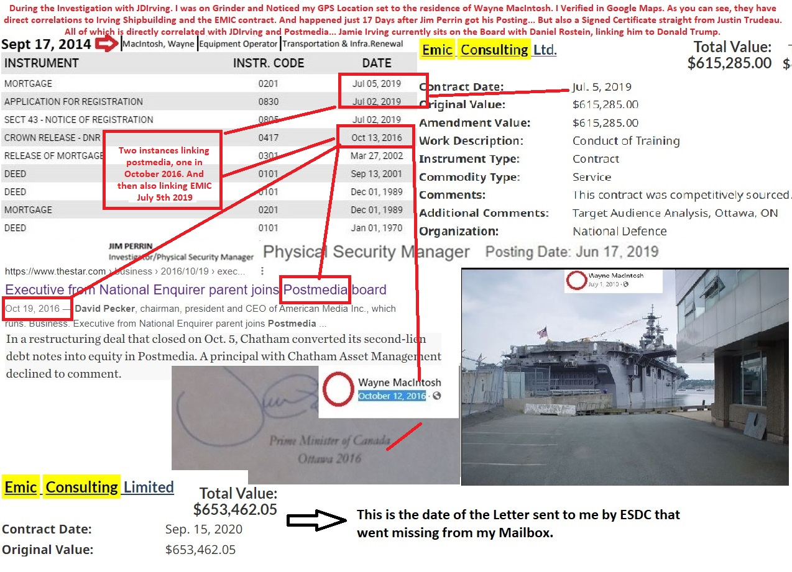

**Image of Target Audience Analysis (TAA) breakdown and lists of references:**

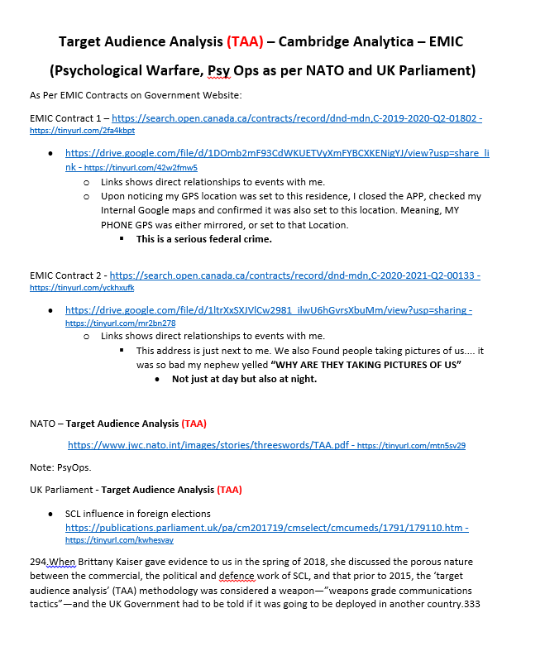

**Image showing official NATO documentation defining Target Audience Analysis (TAA) as a component of Psychological Operations (PsyOps).:**

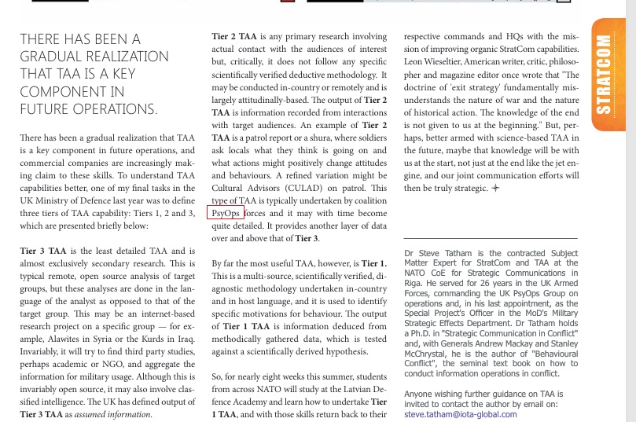

**Image showing metrics used in TAA when evaluating unmarried males (me):**

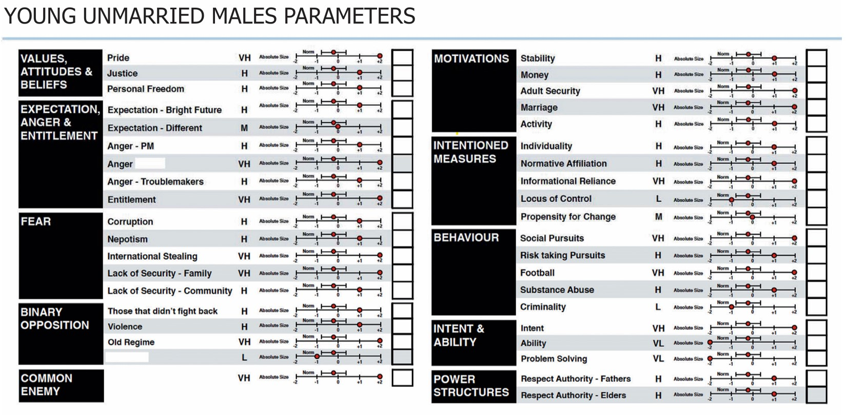

**You stated that you reported “children were threatened”.**

**Q1. Whose children were threatened and what are the children’s names?**  
**A1.**  
The children who were threatened are relatives of mine. I will not disclose their names. These are minors who were surveilled by an unknown individual claiming to be a “Private Investigator,” and I have every reason to believe law enforcement either ignored or concealed this incident. Considering the level of retaliation I have personally faced, and the lack of any case number or meaningful follow-up, disclosing their identities would put them at further risk.  
It has been over several years since this matter was raised, and despite being shared with multiple RCMP and HRP officers, including those linked to serious internal misconduct, no one has contacted me. The CRCC has shown an institutional failure in protecting those involved and preventing harm.

**Q2. On what date or approximate date were those children threatened?**  
**A2.**  
Between **December 10th and December 12th, 2019**, over the course of several days.

**Q3. Please describe the nature of the threats that were made towards the children.**  
**A3.**  
The children were stalked by an unidentified vehicle over several days. Both the children and their parents noticed the vehicle's repeated presence. Eventually, one of the parents confronted and boxed in the vehicle. The driver identified himself as a “Private Investigator” and admitted to monitoring people in the area. This constituted targeted surveillance of minors, with no lawful explanation provided.

**Q4. Who made the threats towards the children?**  
**A4.**  
The identity of the individual remains unknown. When confronted, the person claimed to be a “Private Investigator” and was visibly shaken. While no direct verbal threats were made, his admission to active surveillance in a residential area where children were present and waiting for their bus is deeply concerning. The individual never clarified who had hired him or why the surveillance was taking place.

**Q5. Where did this incident take place (please provide town/city and province)?**  
**A5.**  
The incident occurred on **Myra Road in Porters Lake, Nova Scotia**. Although I did not live there at the time, that address was previously listed on my résumé, submitted exclusively to J.D. Irving during a job application in late 2018 or early 2019. I believe the use of that outdated address as a point of surveillance raises serious questions about how that information was accessed and for what purpose.

**Q6. Were you present when these threats were made towards the children?**  
**A6.**  
No, I was not present at the time. In **late July 2020**, I spoke with someone directly involved. During our conversation, I referenced a letter I was preparing to send — which I eventually released on **August 5th, 2020**. That letter appeared to have immediate political consequences, including the resignation of Nova Scotia Premier Stephen McNeil the following day.  
When I raised the incident from December 2019, the individual I spoke with gasped in recognition and confirmed the details, adding that neighbours were also aware of the situation and had reported it to the RCMP — twice — yet received no response.

**Q7. Are you the parent or legal guardian of any of the children who were threatened?**  
**A7.**  
No. I am a cousin of the children involved.

**Q8. To whom at the RCMP did you report these threats and on what date or approximate date did you do so?**  
**A8.**  
To the best of my understanding, the initial threats were reported to the RCMP by neighbours between **December 10th and 12th, 2019**. I was informed of this after the fact, and to my knowledge, there was no meaningful follow-up by RCMP at that time.

I personally reiterated the concerns in the **main email thread beginning in September 2021**, and have continued to reference the threats up to the present. The incident was also documented in The Wolf and the Neural Network – ALPHA, released publicly on **July 11th, 2022**.

Further, the matter was reported directly to **Jessica of the RCMP detachment in Sheet Harbour**, though her response demonstrated clear bias. This bias is clearly audible in a **recorded conversation from May 24th, 2023**, which was followed by retaliatory behavior from **Jessica Welke**.

This was also reported to CRCC.

**Q9. What, if anything, are you alleging a member(s) of the RCMP did that was improper in relation to this incident?**  
**A9.**  
I allege that RCMP members failed to take any action when the incident was reported — either by the neighbours in 2019 or by me in multiple follow-ups. Instead of investigating, my concerns were dismissed without review. I was accused of lying and subjected to threats and intimidation.  
This incident fits into a broader pattern of retaliation and misconduct linked to RCMP, HRP, J.D. Irving, and others. It connects to surveillance activities involving **9330 Highway #7, Stillwater NS**, a location tied to confirmed GPS manipulation and spyware, as well as the resignation of senior officials.  
The RCMP’s failure to act, combined with their targeting of me, points to systemic abuse and an effort to suppress the truth.

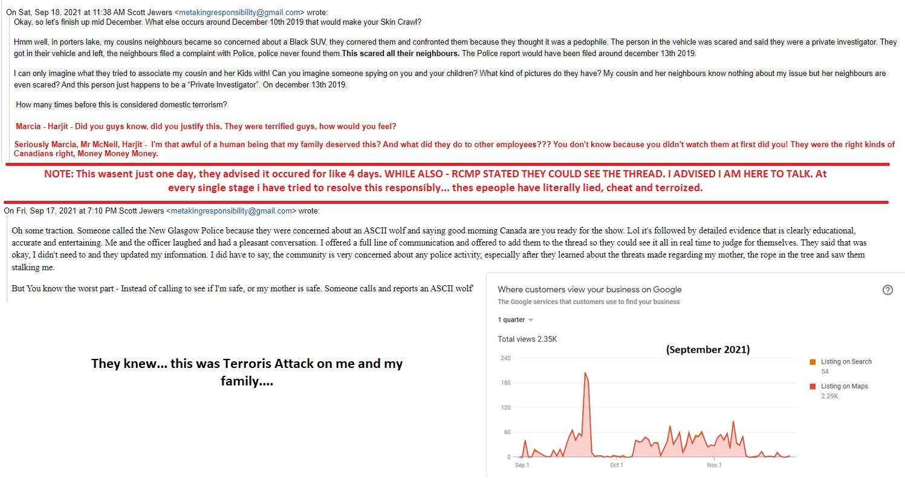

**You stated that you reported that your “property was stolen”.**

**Q1. Please describe your property that was stolen.**

**A1.** There were four separate incidents involving theft or disappearance of property, the most significant being:

**May 27, 2019 – Theft of Wallet:**  
My wallet was stolen during a period that would later emerge as a major nexus point in The Wolf and the Neural Network investigation. This theft initiated a sequence of events involving **Halifax Regional Police (HRP)**, **RCMP**, and intelligence-linked retaliation that remains unresolved.

I retrieved my wallet from **HRP headquarters on June 5, 2019**. Within 12 days of this recovery, **J.D. Irving** posted a job opening — **Physical Security Manager (19002740)** — which was ultimately filled by **Jim Perrin**, then Commander of HRP’s Criminal Investigation Unit and Superintendent. This transfer appears linked to broader institutional movement following the release of the **Wortley Report** and public controversy surrounding street checks.

This timeline overlaps again with events on **November 19, 2019**, when:

* I received an unsolicited job opportunity email from the Government of Canada.
* **Chief Dan Kinsella** publicly announced an apology for street checks, reasonably part of the justification for Perrin’s transfer.
* **Jim Perrin** began his role at J.D. Irving.
* **TorStar** closed its Halifax bureau — a media outlet that, alongside **Postmedia**, was under scrutiny for collusion involving **David Pugliese**, J.D. Irving, and SaltWire, dating back to March 2019.

**May 2019** serves as a key nexus, linking forward to major events, including:

* **November 19, 2019**, when several institutional and media shifts occurred.
* **April 18, 2019**, an earlier anchor date that ties into the investigation’s structural chronology.
* **January 4, 2023**, when **Irving Shipbuilding** was awarded a **$1.6 billion federal contract** — tracing back to developments initiated in May 2019.

This timeframe also aligns with the removal of **EMIC contracts** from the Government of Canada’s contract portal (<https://search.open.canada.ca/contracts/>), and events surrounding:

* The **96.6% RCMP no-confidence vote** against Chief Dan Kinsella.
* **Target Audience Analysis activities**, including high-interest engagements involving **Leyla Li** and **Duke University** on **January 5–6, 2023**.

Each of these connections illustrates how a seemingly isolated property theft evolved into a larger pattern of suppression, surveillance, and institutional reshuffling directly tied to national security and political exposure.

**September 15, 2020 – Critical correspondence from the Office of the Privacy Commissioner (OPC) and Employment and Social Development Canada (ESDC) went missing from my mailbox. This mail pertained to matters of jurisprudence and the application of PIPEDA (Personal Information Protection and Electronic Documents Act).**

**EMIC Contract #2 and Residence B:**

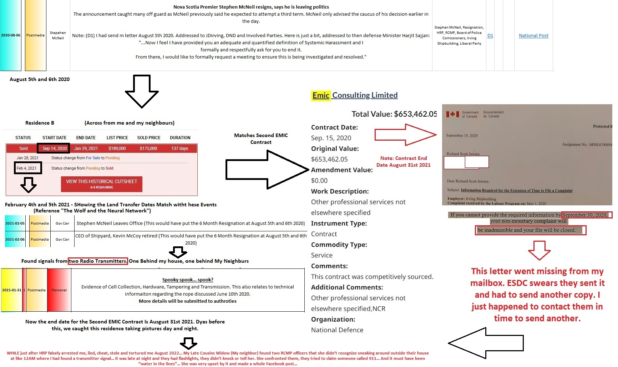**PIPEDA Argument:**

Image of PIPEDA Argument (AI Rates 85- 90% at University Level with aesthetic tweaks):

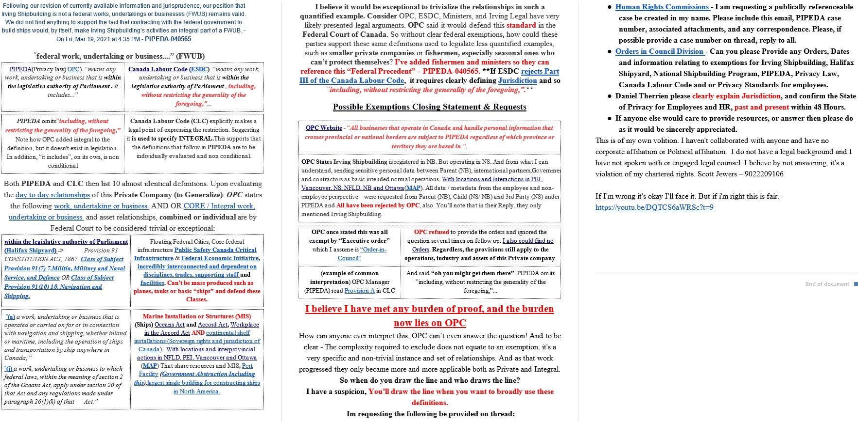

**Statement on Events: August 2–3, 2022 – HRP and NSHA Misconduct**

On **August 2, 2022**, I went to **Halifax Regional Police (HRP) Headquarters** to file a formal complaint. Prior to this, on **July 11, 2022**, I had submitted The Wolf and the Neural Network – ALPHA version to the “Main Email Thread.” It contained over **400 chronologically ordered data points**, most of which were **hyperlinked and cross-referenced**, outlining serious allegations implicating multiple institutions.

Rather than reviewing any part of this report or allowing me to file the complaint, HRP **retaliated**. Officers falsely claimed they were retrieving a complaint form. Instead, they returned and **arrested me without cause**.

### ****False Claims and Retaliation****

NSHA staff would later fabricate a claim that I was “protesting” at HRP — a claim that was never made by HRP themselves, and is not found anywhere in their official records. In fact, **HRP Professional Standards reviewed the video**, and it clearly shows that I was **calm, composed, and respectful** — not protesting in any form.

There is **no official statement from HRP officers explaining why I was taken to NSHA**. This lack of documentation is a serious procedural failure.

I remained in handcuffs for over **10 hours**, denied access to legal counsel **at least five times**. When I again requested a lawyer before a forced blood draw, I was told: “What’s the problem if you have nothing to hide?”

### ****Evidence of Coordinated Retaliation and Privacy Violations****

I was detained alongside another individual — a homeless man — who was visibly under the influence and admitted his state. He looked at me and said, “Man, if you’ve got a problem, this is the right place to be.”

That man — **not me** — was transferred to **Mount Hope** before I was. Disturbingly, **my bookbag was sent with him**, not with me. The following morning, he approached me and warned that **police had gone through my bag**. He even joked, asking if I wanted to play rock-paper-scissors for one of the twenty-dollar bills inside.

My bookbag had a **large sticker on it with my name — “SCOTT” — clearly visible**. Anyone seeing that person with the bag could reasonably assume he was Scott. The next day, the individual appeared **extremely pale and withdrawn**, suggesting he may have been in **medical distress**, likely due to **withdrawal**. He was removed shortly after.

This indicates that not only was **my personal property and identity mishandled**, but the individual may have been placed in **immediate physical and medical danger**, as well as **long-term risk**, by being exposed to officers and their "special interests."

This mirrors what **Jonathan Jefferies**, **Ron Legere**, and **Patrick Curran** did when they **falsely accused me of sexual assault** — a fabricated charge that allowed **HRP to retaliate, threaten, and abuse** me under the false cover of legitimacy.

My **wallet contained sensitive identification, banking details, and my health card** — all of which are classified as **Personal Health Information (PHI)** under both **NSHA policy** and legal definition as confirmed by **Karen Hornberger, Director of Privacy (NSHA)**.

This PHI breach should have been immediately reported to **SIMS (NSHA’s Security & Information Management System)** for investigation. It was not.

Instead, **Karen Hornberger** and **Douglas Grant (CPSNS)** later issued **false statements** regarding my wallet and bookbag — despite the fact that **Mount Hope notes clearly confirm the bag arrived before I did**, alongside another client. Their lies are documented on the **very first page** of Mount Hope’s official record.

### ****Documented Cover-Up and Systemic Fabrication****

I have in my possession:

* **Audio recordings**
* **Video evidence**
* Nearly **200 pages of internal notes** from NSHA and HRP

These materials **prove** that official records **do not match the events** captured in the recordings. From **August 2–12, 2022**, I was subjected to abuse, lies, and fabrication of records by multiple staff members at NSHA.

These include:

* Falsified statements that I was protesting
* Incorrect claims that I lived with my parents
* Omission of relevant work history
* Entirely fictitious mental health narratives

They operated under the assumption that each previous staff member “must be telling the truth,” and therefore I was the liar. This recursive failure created a **self-justifying chain of negligence** that allowed each party to escalate harm without accountability.

When you examine the triage notes and subsequent records, you will notice something critical: **nowhere** do they clarify whether I was or was not protesting — because to clarify would have directly contradicted the triage record, exposing it as false from the start. Instead, they left the record ambiguous and smeared with innuendo, ensuring deniability and shielding themselves from liability.

### ****This Was Not Negligence — It Was Malice****

What happened was not a bureaucratic failure. It was **targeted retaliation**. These actions meet the legal threshold for:

* **Obstruction of justice**
* **Malicious prosecution**
* **PHI violations**
* **Professional negligence**
* **Hate crimes**
* And, potentially, **human trafficking**, as defined by the coordinated, unlawful detainment, transportation, and psychological coercion involved.

### ****My Offer to CSIS and the People of Canada****

As part of my contribution to **national security and institutional reform**, I have formally offered to:

* **Testify under oath**
* **Undergo a polygraph**
* In full **public view**, before **all of Canada**, regarding the events of **August 2–12, 2022**

I stand by every claim. The evidence is irrefutable.

[www.TheWolfAndTheNeuralNetwork.com](http://www.TheWolfAndTheNeuralNetwork.com/)

Image evidence confirms that NSHA notes list the contents of my wallet and explicitly state that the book bag and belongings were brought in with a previous client. Multiple NSHA staff members later lied about this fact:

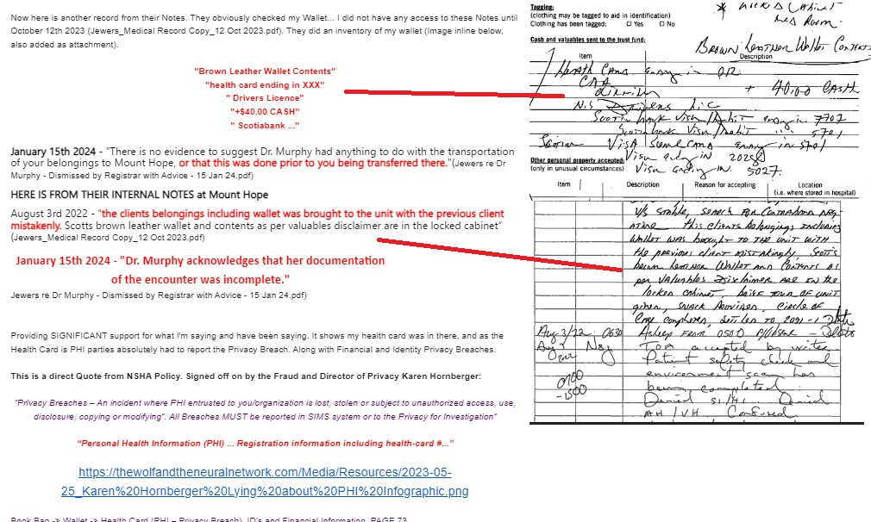

**August 31, 2023 — NSHA Serves False Trespass Notice**

On **August 31st, 2023**, I was served by a bailiff acting on behalf of the **Nova Scotia Health Authority (NSHA)**. The envelope contained **three copies of the same document**, including carbon copies. A scanned version can be found here: <https://tinyurl.com/kvf7pvj6>.

The document falsely claims that I, **Scott Jewers**, am being trespassed from **NSHA hospitals** — which are public property and constitutionally protected under the **Canadian Charter of Rights and Freedoms** as essential health services.

It alleges that I was **physically present at an undisclosed NSHA location on August 22, 2023**, and that **Anthony Jocko** read the trespass notice to me in person at this location. It further states that **Vishwaraj Gohil** witnessed both my presence and the reading of the notice by Jocko.

This is entirely **false**:

* I was **not present at any NSHA location** on or near August 22, 2023.
* I was **not read any document**, nor was I **contacted** by NSHA in any way.
* I have **never caused an incident at any NSHA facility** that would warrant such action.

The bailiff who delivered the documents told me they were simply given a **name and phone number** — and expressed confusion about the situation, stating it was not typical procedure. Furthermore, upon reviewing the document, the handwriting appears **uniform across the form**, suggesting that **the same person may have filled out every section**, including:

* The name and information for the **Security Guard**
* The **witness signature**
* And possibly the **subject line itself**

This raises serious concerns of **document falsification** — including the **forgery of signatures** of both a security officer and a witness.

Image showing the three copies of Trespass notice, Pink, Yellow and White. And that the same person completed the forms, including signing for the witness:

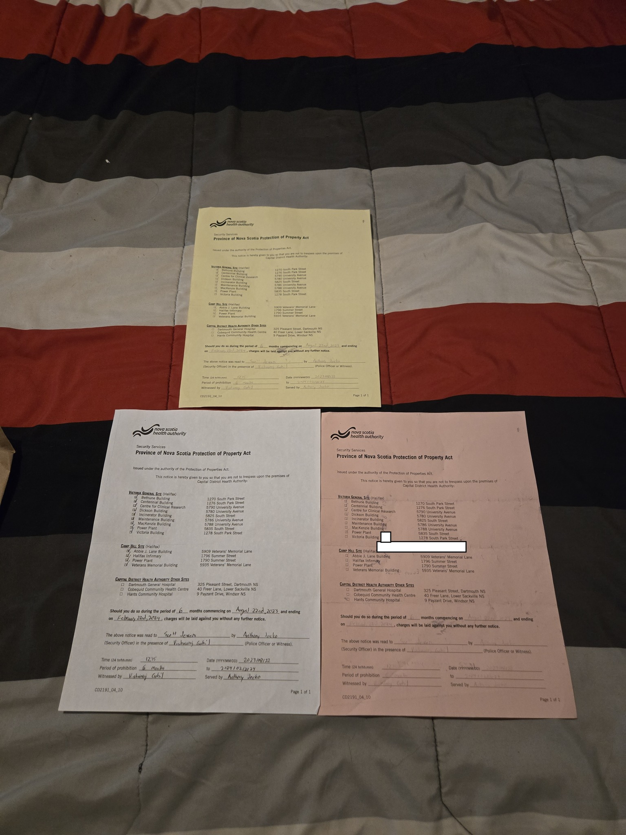

**Q2. On what date or approximate date was your property stolen?**  
**A2.**  
There were four key incidents involving theft or disappearance of property:

* **May 27, 2019** – Wallet stolen
* **September 15, 2020** – Government correspondence (mail) intercepted or stolen
* **August 2–3, 2022** – Wallet and bookbag mishandled and accessed without consent
* **August 31, 2023** – Trespass notice served based on forged/fraudulent documents involving identity misrepresentation

Q3. Who stole your property?

A3.**May 27, 2019 –** The individual(s) responsible for the theft remain unidentified. On **May 31, 2022**, under the direction of legal counsel (despite Scott Jewers pleading against it), a **Freedom of Information (FOI)** request was submitted to Halifax Regional Police regarding the stolen wallet. The FOI response stated the file was **locked due to someone else’s privacy rights**.  
Notably, that same day, **Kevin Mooney**, President of **Irving Shipbuilding**, **resigned** — a significant development given the surrounding context. While direct attribution remains speculative, there is a **compelling body of circumstantial evidence** connecting the event to **Jim Perrin** (former HRP Commander) and **HRP** more broadly.

**September 15, 2020 -** A critical piece of mail from **Employment and Social Development Canada (ESDC)** went missing from my **mailbox**. ESDC has since confirmed that the original letter **was sent**. When they reissued a copy, it was sent with enhanced security — requiring me to **go to the post office and sign for it in person**. This clearly indicates that the original letter was either **intercepted or stolen**. This stolen correspondence related to **jurisprudence and PIPEDA/PIEPDA applicability**, and its contents had **serious legal implications**. If I had received it and remained silent, no one could have known what power or leverage that document afforded me. Its disappearance made it a **critical point of interference**.

Compounding this, it is now a **non-contestable fact** that my GPS was, without my consent, **remotely set to 9330 Highway #7, Stillwater, Nova Scotia**. This is **spyware activity**, either planted by:

* A **law enforcement entity**,
* A **malicious third party**,
* Or a **foreign state actor**.

This is not speculation. The address in question aligns with the known **EMIC contracts** — a company with ties to **Cambridge Analytica**, and whose contracts **match the start date** of **Dan Kinsella** becoming **Chief of Police of Halifax Regional Police**.

Of further concern:

* **EMIC Contract #2** directly correlates with **September 14, 2020** (one day before the stolen letter), and **February 4, 2021**, coinciding with:
  + **Stephen McNeil’s resignation**, and
  + **Kevin McCoy’s retirement** (which occurred exactly **6 months after** my formal letter/email advised this should be resolved within that window).

There are also signs of a possible **IMSI catcher** (cellphone interception device) operating in this period — consistent with other forms of targeted surveillance and identity theft.

Given that the stolen letter likely included **case numbers and personal data**, its interception would have enabled malicious actors to **impersonate me**, and even frame me — fitting the broader pattern of **digital and physical identity theft**, **spyware deployment**, and **evidence manipulation** that I’ve been documenting for years.

**August 2–3, 2022 –** I was **falsely arrested** after attempting to file a formal complaint and speak directly with **Chief Dan Kinsella**. My intent was to warn him that it appeared **someone may have been trying to frame him** — a concern I believed was both **institutionally significant** and in the **public interest**.

I had exhausted every other available channel and had repeatedly asked for someone in authority to **step forward and address the situation**. No one did.

It now appears that the arrest and everything that followed was triggered by **officers overhearing my conversation**. Whether the resulting response came solely from **HRP**, another oversight body, or was executed in coordination with **NSHA**, what followed was a cascade of **serious procedural failures** — each compounded by **deliberate misrepresentations** and **false documentation**.

However, **"mistakes"** do not explain the actions of:

* **Kristen Holm**
* **Karen Hornberger**
* **Douglas Grant**

Their conduct — including **record fabrication**, **obstruction of legal rights**, and **knowingly false statements** — was not administrative error. It was **malicious**, **calculated**, and **retaliatory**.

These actions were not isolated misjudgments. They reflected **clear forethought**, coordination, and **intent to harm**.

**August 31st, 2023 –** My **identity was stolen**, and the **Nova Scotia Health Authority (NSHA)** issued a trespass notice based on **completely fabricated claims**. The document falsely alleges that I was present at an undisclosed NSHA location on **August 22nd, 2023**, and that **Anthony Jocko** read the notice to me in person, with **Vishwaraj Gohil** listed as a witness.

None of this happened.  
I was not at any NSHA facility on or near that date.  
No one from NSHA contacted me, read anything to me, or provided notice in any lawful way.

On reviewing the document, it is clear that **the same person filled out the entire form**, including **forging the witness signature**. This suggests a deliberate fabrication of official documents.

Despite multiple attempts to contact NSHA for clarification, **no one responded**. This establishes that all involved parties were — at minimum — **complicit, compliant, and complacent** in a fraudulent act carried out under the pretense of authority.

Exactly **six days later**, on **September 6, 2023**, **Chief Dan Kinsella** announced his **retirement**. Shortly after, **RCMP Commissioner Dennis Daley** announced there would be an **official apology for Street Checks**.

This incident directly ties back to:

* The **November 19, 2019** TWNN overlap, involving media closures, political resignations, and the J.D. Irving appointment of Jim Perrin.
* The **EMIC contracts**, which **match the start date of Dan Kinsella’s appointment** as HRP Chief — a critical link in the broader surveillance and targeting pattern.

By **August 2023**, it was already well established that I had **completely dismantled the credibility of**:

* **Patrick Curran**, Police Complaints Commissioner
* **Jonathan Jefferies** and **Ron Legere**, HRP Professional Standards

Additionally, **Premier Tim Houston** had **personally shown up on January 29, 2023** — a date of critical significance in this investigation. His involvement is notably connected to **Karen Oldfield**, President and CEO of NSHA, **whom he personally appointed**. This reinforces the direct link between political leadership, NSHA executive oversight, and the escalating pattern of institutional retaliation I was exposing.

At this stage, all parties involved — including NSHA and law enforcement — had **clear motive** to frame me or remain silent. And so, **nobody acted**. Their inaction served their interests.

**Q4. Where was your property stolen from (please provide address including town/city and province)?**

**A4.**

* **May 27, 2019 – Dartmouth, Nova Scotia**
* **September 15, 2020 – Ecum Secum, Nova Scotia** (theft of government correspondence from mailbox)
* **August 2–3, 2022 – Halifax, Nova Scotia**, specifically at the **Halifax Infirmary / QEII** and **Mount Hope** facilities, during the period when I was **falsely arrested, tortured, and sexually assaulted**
* **August 31, 2023 – Halifax, Nova Scotia** (alleged NSHA property). The trespass notice references an event at an **undisclosed location**, believed to be **Halifax Infirmary / QEII**, but **no location was officially stated**, and the event described in the notice was entirely fabricated.

**Q5.  To whom at the RCMP did you report this theft and on what date or approximate date did you do so?**

**A5.** I reported the thefts and related incidents to **Jessica Welke**, **Justin Hall**, **Chad Samford**, and several other RCMP officers over multiple occasions. Despite my repeated efforts to file a formal complaint, I was **refused each time**. None of the officers provided a clear path forward or referred me to an appropriate resource.

I made these reports calmly and reasonably, **pleading for assistance**, yet I was met with indifference and, in some cases, **thinly veiled threats**. Officers repeatedly stated, “We don’t know who you would file a complaint with,” despite knowing the severity and legitimacy of my concerns.

Q6. What, if anything, are you alleging a member(s) of the RCMP did that was improper in relation to this incident?

A6. I am alleging that multiple members of the RCMP:

* **Knowingly covered up abuse**, including sexual assault and coordinated retaliation,
* **Retaliated** against me for reporting misconduct,
* And **used the Mental Health Mobile Crisis Team (MHMCT)** as a proxy tool to **terrorize me**, fabricate a false record, and avoid opening formal police cases.

Rather than investigate the serious allegations I raised, members of the RCMP either obstructed or diverted the process entirely. These actions were not isolated mistakes — they formed a **deliberate pattern of institutional retaliation** and **systemic abuse**.

### Documented Pattern of Improper Conduct Includes:

* **Use of MHMCT as Retaliatory Tool**:  
  After I posted a May 24, 2023 audio recording of my call with **Jessica Welke (RCMP Sheet Harbour)** — where someone in the background can be heard saying "**GOOD**" in response to me describing abuse — I published it publicly on **May 26, 2023**, warning others of what was happening. The very next day, I received a call from MHMCT. No call came from Jessica. When I followed up the following Monday, I spoke with **Justin Hall**, who acknowledged the concern but **Jessica Welke never called me back**.

Image showing Facebook Post made May 26th 2023, 1 day before MHMCT contacted me, anticipating retaliation and asking people to listen. May 27th 2023 i would receive a call from MHMCT and no call from Jessica Welke:

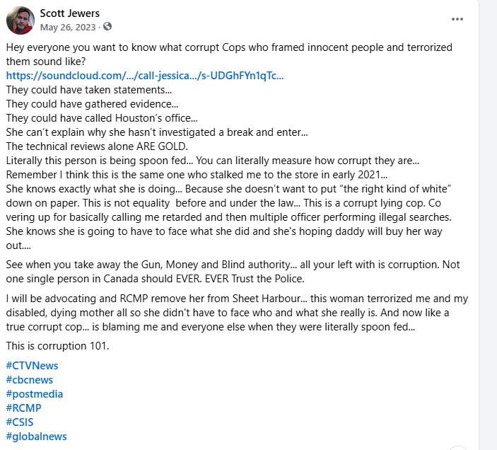

Image showing YouTube video and link to the recorded call between Jessica Welke and Scott Jewers May 24th 2023:

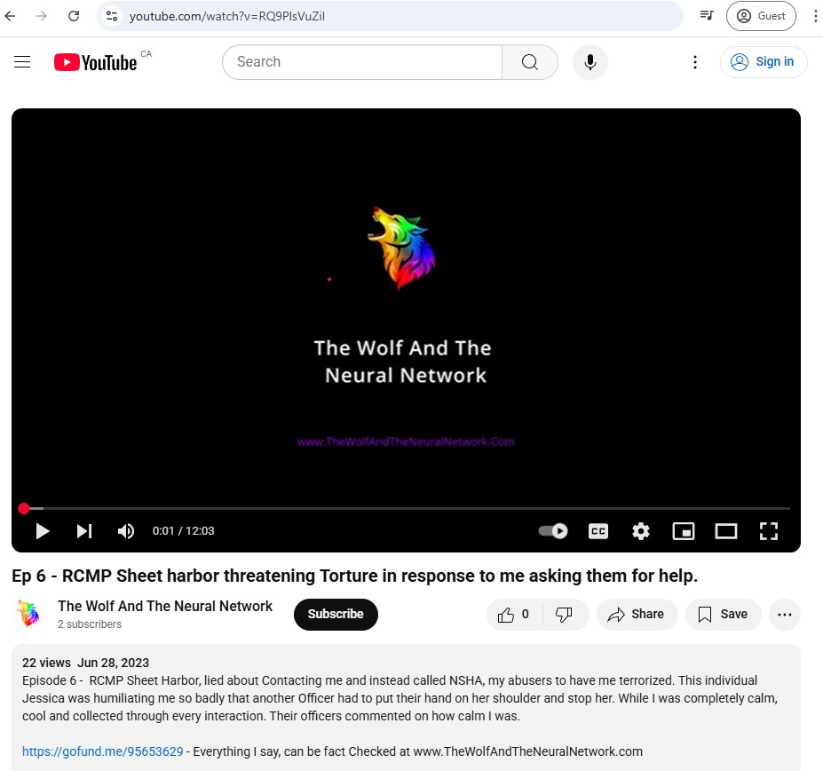

* This sequence — audio evidence, public exposure, followed by **mental health-based retaliation** — forms part of a **calculated strategy** to silence me and build a false narrative to shield the officers involved in my false arrest and prior abuse, particularly from **August 2022**.
* **Ongoing Use of MHMCT to Manufacture a False Record**:  
  Officers including **Sherry Charant**, **Zachary Lechane**, and **Krista Pye**, repeatedly refused to open formal cases and instead used MHMCT as a stand-in to escalate retaliation and construct a parallel mental health narrative — one that could be manipulated to justify ongoing denial of due process.
* **Censorship and Evidence Suppression via EMIC Contract Deletion**:  
  Around the same time, the **EMIC contracts** were deleted from [search.open.canada.ca/contracts](https://search.open.canada.ca/contracts/). This occurred while **Halifax Regional Police** conducted their **historic vote of no confidence** against **Chief Dan Kinsella**, where **96.6% voted no confidence**.  
  I was actively emailing the “Main Email Thread” throughout **October 2023**, documenting the contract removals. I later demonstrated that the contracts were still retrievable via **Wayback Machine**, which is **admissible evidence in Canadian court**. The timing and deletion suggest an attempt to **suppress critical evidence** tied to federal surveillance contracts and misconduct.

IMAGE Showing EMIC Contracts were deleted, and i contacted Main Email Thread advising of this:

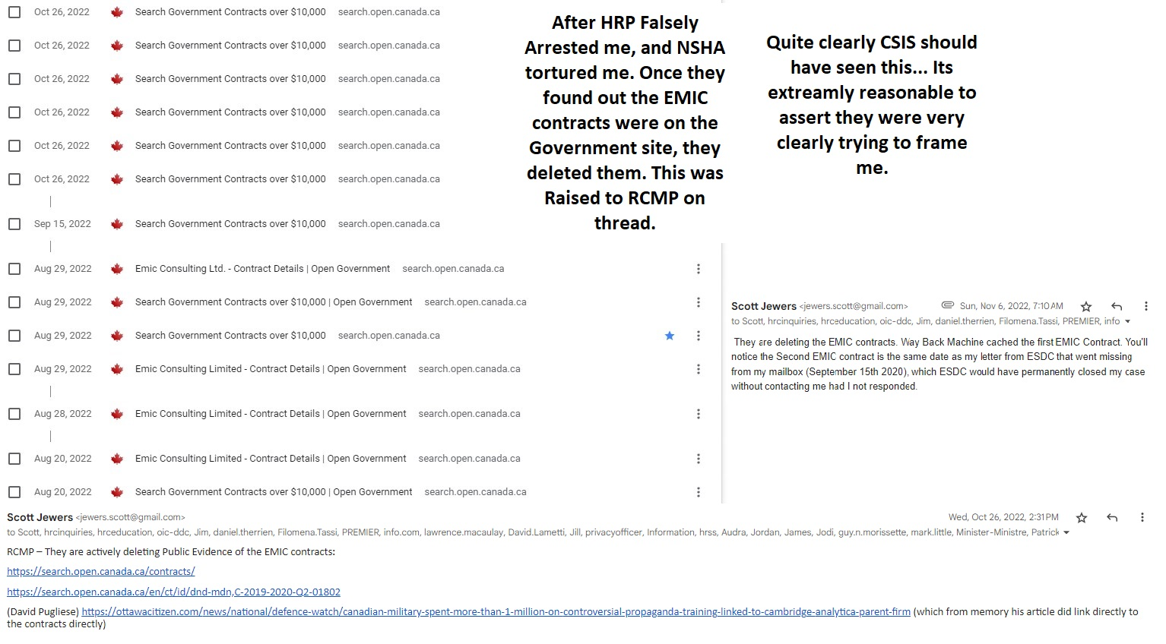

Image showing the EMIC Contract dates also match the Star Dates for HRP Chief of Police, Dan Kinsella:

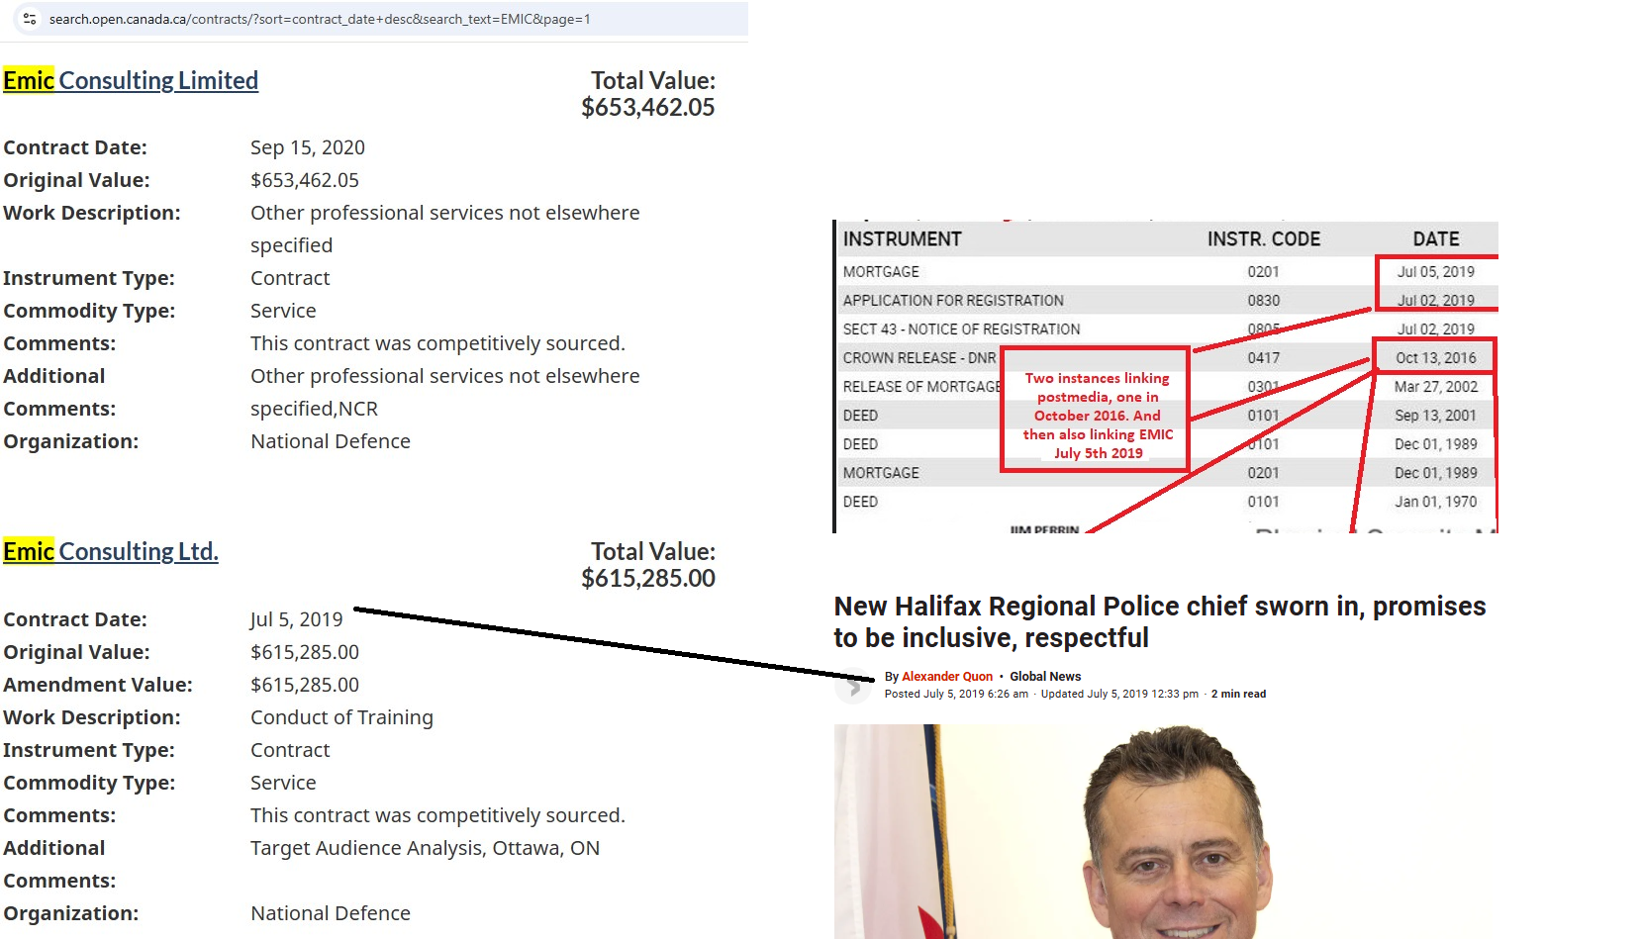

* **Corporal Atwell – Musquodoboit Harbour Detachment**:  
  On **August 22, 2024**, **Corporal Atwell** showed up at my residence and **laughed in my face** when I raised concerns about the sexual assault and presented related evidence. I asked him how to file a formal complaint. He said he didn’t know but would get back to me. **He never did.**  
  Instead, he returned and **filed a false report**, which I now have **on audio recording** — lying about what was said and actively **bullying me** during our conversation. When I pushed again for a case to be opened, they **once more referred me to MHMCT** instead of taking legal action.

The last I heard from **Corporal Atwell**, he said he would contact me in **five days**. That was **over 219 days ago**.

**You stated that you reported a “sexual assault”.**

Q1. Who was sexually assaulted and by whom?

A1. While I do not have the **exact names** of the individuals responsible, I can identify them **functionally** — meaning I know their **roles**, **locations**, and **involvement** during the time of the incident. The individuals involved were **staff members or agents** connected to **Nova Scotia Health Authority (NSHA)** and/or **law enforcement personnel** present during my **detainment and transfer between Halifax Infirmary / QEII and Mount Hope** on **August 2–3, 2022**.

I am prepared to **testify under oath** and provide supporting evidence, including **audio recordings**, **institutional documents**, and **timeline logs** identifying those present and involved in the chain of custody and care.

**Q2. On what date or approximate date did the sexual assault occur?**

**A2.**August 3rd 2022

**Q3. Where did the sexual assault occur (please provide address including town/city and province)?**

**A3.** Halifax, Mount Hope Hospital (After i was falsely arrested for going to HRP to file a complaint)

**Q4.  To whom at the RCMP did you report this sexual assault and on what date or approximate date did you do so?**

A4.I initially reported the basis of the sexual assault on the night of **August 3, 2022**, the same day it occurred, via the **Main Email Thread**, which included **77 recipients across various institutions**, including RCMP, HRP, NSHA, and legal oversight bodies. At the time, I was actively fearing further retaliation.

Specifically, I reported the assault or referenced it directly to the following RCMP members and related officials over the course of 2022–2023:

* **Jessica Welke**
* **Justin Hall**
* **Chad Samford**
* **Sherry Charant**
* **Zachary Lechane**
* **Krista Pye**
* **Jonathan Jefferies** (HRP Professional Standards)
* **Ron Legere** (HRP Professional Standards)
* **Patrick Curran** (Police Complaints Commissioner)
* As well as **Kristen Holm** and her staff member at **NSHA**

Despite this, **no meaningful investigation or protection occurred**. In some cases, the individuals listed either dismissed the claims, retaliated, or allowed further abuse to occur through inaction or complicity.

**Q5. What, if anything, are you alleging a member(s) of the RCMP did that was improper in relation to this incident?**

**A5.** I am alleging that members of the RCMP — particularly those at **Sheet Harbour Detachment** — acted with **retaliation**, **disrespect**, and **willful negligence** regarding my report of sexual assault and related criminal misconduct.

Rather than investigate, RCMP officers:

* **Mocked and humiliated me**, despite my clearly stating I am a **technical expert** presenting evidence of a serious incident.
* **Refused to open a case**, despite my direct request to “open a file and prove me wrong.”
* Engaged in **stalking and intimidation**, particularly in **Sheet Harbour**, where I had been actively involved in local anti-racism efforts.

One RCMP officer — whose name is known to me — **stalked me at a location previously associated with criminal activity**, where an image surfaced showing an **RCMP police vest** found on site. This same officer had also previously targeted me, **making inappropriate and homophobic gestures**, suggesting that I was being targeted, in part, because I am **gay**.

These incidents collectively reflect **systemic misconduct**, not only by individual officers but by the RCMP as an institution.

A particularly disturbing incident occurred on **August 17, 2022**, when I informed **Constable Jessica Welke** that my **GPS had been remotely set to 9330 Highway #7, Stillwater, NS** — a location tied to **EMIC contracts**, which are linked to **election interference and surveillance programs**.

In response:

* Jessica put her hands through her hair and said: “Did you think maybe you’re not supposed to know?”
* Another officer placed a hand on her shoulder to calm her and said something to the effect of: “You need to stop — this is way above our pay grade.”

This occurred after I had raised concerns about **federal crimes**, including **possible hacking** and **evidence planting**.

When I asked, “What do I do? Drive to the address and confront them?”  
Jessica responded: “No! Do not go there.”

This response, along with their behavior, shows that the RCMP:

* Acknowledged the seriousness of the situation,
* Knew these were likely federal-level crimes,
* And yet **refused to document or act**, opting instead to ridicule, suppress, and silence me.

**You stated that you reported “break and enters”.**

**Q1. Please provide the address (including town/city and province) of each place that your reported to have been victim of a break and enter.**

A1. **January 29, 2023**, shortly after **1:30 AM**, I was at the hospital with my mother, who passed away that morning. While I was there, **Premier Tim Houston** also appeared at the hospital.

That same morning, **neighbours observed lights moving around inside my residence**, despite the home being unoccupied at the time. The address in question is:

**[Full Address – if you would like to include it here, e.g., Street Name, City, Province]**

Additionally, a **family member at a Tim Hortons location nearby** reported that a **stranger entered the store**, began talking about being with **CSIS**, and then abruptly left. Notably, **neither my neighbour nor the family member knew about each other's experiences** at the time — they came forward independently.

These events strongly suggest that my residence may have been **entered without consent or lawful justification**, during a moment of extreme personal vulnerability, and potentially in connection with **state surveillance or intimidation tactics**.

Image showing Break and Enters, CSIS events as well as Tim Houston showing up were all mentioned to Main Email Thread February 17th 2023:

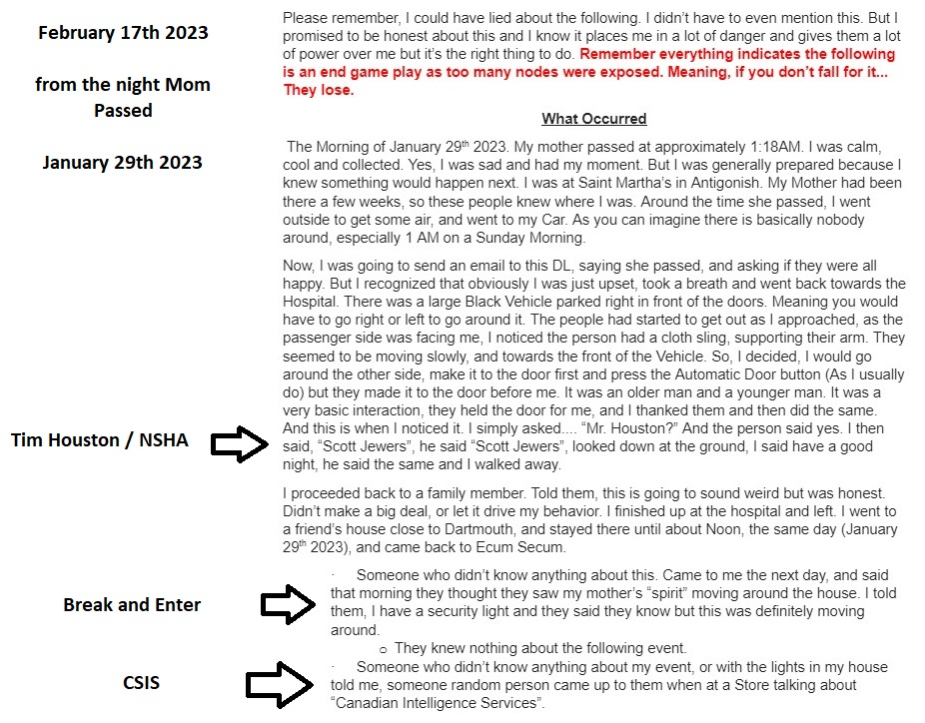

**Q2. On what date(s) or approximate date(s) did each of those break and enters occur?**

**A2.** January 29th 2023, after 1:30AM

**Q3.  Do you know who committed the break and enters?**

**A3.**I do not have direct evidence identifying the individual(s) who entered my residence. However, based on the **timing** of the incident — occurring in the early hours of **January 29, 2023**, the same night my mother passed away — and in light of the **ongoing pattern of targeted retaliation**, I strongly suspect that the break-in was connected to **members of the RCMP**, or **individuals acting on behalf of institutions involved in framing, torturing, and terrorizing me**.

These are the same parties who have **fabricated false records**, **covered up a sexual assault**, and engaged in **systematic retaliation** throughout my case. Given the gravity of my mother’s passing, and the escalating legal exposure for those involved, it is highly likely this act was intended to:

* **Justify or escalate their previous actions**,
* **Create a false narrative**,
* Or even portray me as unstable — for example, by suggesting that “I imagined lights in my house.”

But there **were witnesses**, and I have withheld their identities to **protect them** from becoming targets themselves. This is precisely the tactic I believe these individuals rely on: forcing victims to **expose the most vulnerable people in their circle**, so they can be discredited or silenced.

In short, I believe this break-in was not random — it was part of a broader campaign of **institutional abuse and psychological warfare** designed to destroy credibility and avoid accountability.

**Q4. Did you witness the break and enters?**  
**A4.**  
No. The incident was **reported to me by noon on January 29, 2023** by neighbours who observed suspicious activity, including **lights moving around inside my home**, while I was at the hospital.

**Q5. What is your connection to each of the places that were victims of the break and enters?**  
**A5.**  
The location is **my personal residence** — it is my **primary home**.

**Q6. To whom at the RCMP did you report each of the break and enters and on what date or approximate date did you do so?**  
**A6.**  
I reported the incident via the **Main Email Thread** on **February 17, 2023**, which included **over 77 recipients**, many of whom are connected to RCMP, HRP, NSHA, and oversight bodies.  
In that message, I **clearly outlined the context**, including:

* The **break-in**,
* The **suspicious timing** coinciding with my mother's death,
* And the **unusual presence of Premier Tim Houston** at the hospital that morning.

**Q7. What, if anything, are you alleging a member(s) of the RCMP did that was improper in relation to this/these incident(s)?**  
**A7.**  
I am alleging that members of the RCMP:

* **Failed to respond** to credible evidence of a break and enter at my home,
* **Ignored witness reports**,
* And refused to investigate, despite being **formally notified through multiple channels**, including the Main Email Thread.

Given the **timing** — within hours of my mother's death — and the **broader pattern of harassment, surveillance, and retaliation**, it is reasonable to believe the RCMP either:

* **Deliberately ignored the incident**,
* Or were **complicit in allowing it to happen** as part of a continued campaign to intimidate and destabilize me.

Their inaction fits a documented pattern of:

* **Retaliation** against my protected disclosures,
* **Negligence toward legitimate safety concerns**,
* And **institutional shielding** of those already implicated in prior abuses.

**You stated that you reported “possible threats” against your disabled mother.**

**Q1. What is your mother’s name?**  
**A1.** Debbie Jewers

**Q2. On what date(s) or approximate date(s) was your mother threatened?**  
**A2.** From approximately **December 10, 2019** through to **January 23, 2023**.

**Q3. Please describe the nature of the possible threats that were made towards your mother.**

**A3.** The nature of the threats against my mother was **coercive, psychological, and deeply targeted**, particularly given her **disabled status**. These threats appeared as part of a broader pattern of intimidation connected to my whistleblowing activities involving **J.D. Irving**, **Irving Shipbuilding**, **HRP**, and other institutional actors.

On **December 10, 2019**, I attended a government job interview in Halifax. The interview went extremely well, but **neither I nor the panel mentioned my most recent employer — Irving Shipbuilding — which was highly unusual** given it was prominently listed on my résumé. Notably, I had submitted a formal complaint to Irving Shipbuilding **just 24 hours earlier**.

Roughly **8 hours after the interview**, as I was leaving the city, a Halifax Regional Police vehicle pulled in behind me and asked about a “woman in a nightdress” seen wandering the area. This was a highly specific and disturbing question, as **my mother — who is disabled — was known to wear nightdresses**, and **HRP had previously been involved in welfare checks at her location**.

This encounter occurred shortly after a chain of significant events, including:

* The **theft of my wallet** and involvement of HRP in **May 2019**
* The issuing of the **EMIC contract** on **July 5, 2019**, which is tied to surveillance infrastructure
* My complaint preparation submitted to **DND on November 23, 2019**, just days after the **nexus date of November 19, 2019** — which is linked to multiple major personnel and media movements

Following these disclosures, I experienced:

* **Targeted surveillance**, including SUVs **staking out children**
* A documented near-plane collision (“planecident”) witnessed during that same December cluster of dates
* And increasing intimidation by HRP and affiliated actors

To add to this, the **individual assigned to investigate my complaint against Irving Shipbuilding** was none other than **Jim Perrin**, who had direct involvement with **HRP** during the period I reported misconduct — a clear conflict of interest.

In summary, the nature of the threats against my mother involved **indirect targeting and psychological intimidation**, clearly tied to my efforts to report corruption and systemic abuse. These acts appear **deliberate**, timed to **coincide with formal complaints**, and strategically designed to **create fear and suppress further action**.

Image includes my mother’s nightdresses, the location where the event occurred (with GPS metadata), and what appears to be a possible HRP log entry referencing the incident:

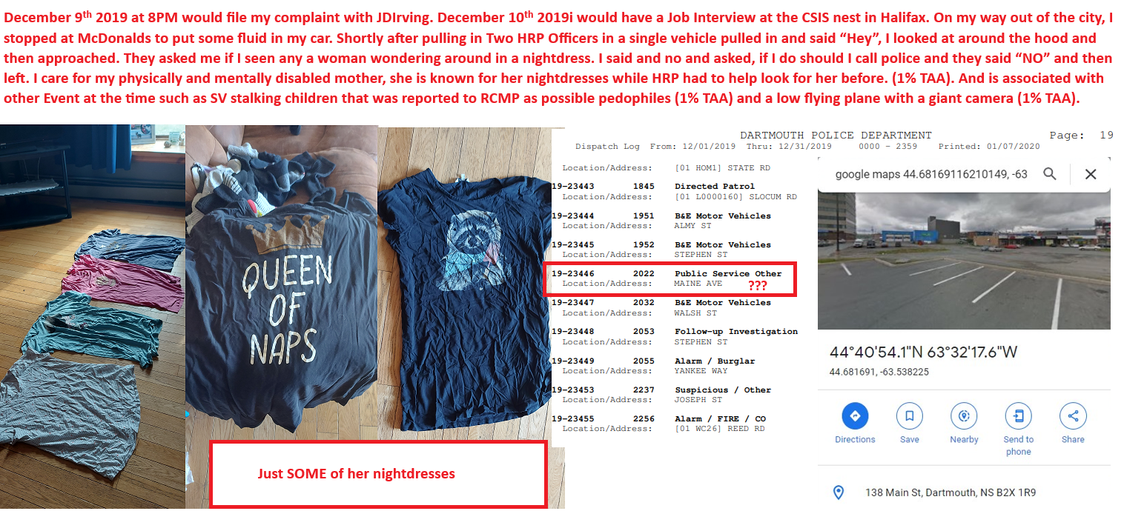

Q4. Who made the threats towards your mother?

A4. While it is difficult to name a specific individual with certainty, the threats toward my mother most likely originated from a **combination of actors**, both directly and indirectly involved. The most **reasonable and evidenced parties** include:

* **Members of Halifax Regional Police (HRP)** — given their prior involvement, the timing of their actions, and their proximity to my family, including an incident involving a reference to my mother’s nightdress shortly after I filed a formal complaint.
* **At least one high-ranking individual within Irving Shipbuilding**, an entity that stood to lose significantly from my disclosures and legal filings.
* **Government officials** or **senior public servants**, who may have participated in or approved covert retaliation due to the political risk and institutional exposure posed by my work.
* **The RCMP**, who had a clear motive to deflect attention and frame a target following the fallout from the **Mark Norman affair**, and to shield systemic misconduct.
* **The Department of National Defence (DND)**, **federal government**, and **media conglomerates** including **Postmedia** and **TorStar**, all of whom had potential interests in suppressing the truth — particularly given the political, economic, and national security implications surrounding:
  + The **EMIC contracts**,
  + The **appointment of Dan Kinsella** (whose sudden transfer from Ontario raises questions),
  + And the **November 19, 2019 nexus date**, which links multiple institutional changes, resignations, and media closures.

Taken together, these parties had both **motive and opportunity**, and their actions appear to have been part of a coordinated effort to **silence me** by targeting the most vulnerable person in my life — my disabled mother.

**Q5. Where did this incident take place (please provide town/city and province)?**

**A5.** The incident took place in **Dartmouth, Nova Scotia**, specifically in the **McDonald’s parking lot on Main Street**.

**Q6. Were you present when these possible threats were made towards your mother?**

**A6.** Yes, I was present at the time.

**Q7. To whom at the RCMP did you report these threats and on what date or approximate date did you do so?**

**A7**.I began reporting these threats to the RCMP in **September 2021**, and have continued to do so **through to the present**. These reports were made both directly and via the **Main Email Thread**, which included dozens of institutional and government recipients. The threats coincided with **multiple other serious events**, many of which are documented and time-stamped in The Wolf and the Neural Network (TWNN) timeline

**Q8.** What, if anything, are you alleging a member(s) of the RCMP did that was improper in relation to this incident?

**A8.** I am alleging that RCMP members:

* **Ignored credible and substantiated reports** of threats against a disabled individual,
* **Obstructed accountability**, despite having access to overwhelming evidence, and
* **Actively attempted to discredit me**, rather than address the misconduct I reported.

On **July 11, 2022**, I submitted TWNN – Alpha to oversight and law enforcement agencies, including RCMP. It contained over **400 chronologically organized data points**, with more than **90% hyperlinked and cross-referenced**, clearly outlining:

* The **timeline of abuse**,
* My **false arrest**,
* The **sexual assault**, and
* The **coordinated institutional retaliation**.

From that point forward, **every RCMP interaction with me occurred in full knowledge of that evidence base**. They could have easily opened a legitimate dialogue by saying, “Let’s talk about November 19, 2019,” and reviewing the material. Instead, they acted to **conceal it**.

On **September 17, 2022**, I was contacted by someone claiming to be with **New Glasgow RCMP**, referencing a harmless **ASCII wolf** I had included in my email signature. I fully cooperated, offered to add them to the email thread for transparency, and clearly stated that **something serious had happened**.

Instead of following proper procedure, the RCMP appeared to be **laying the groundwork for a false case against me** — a retaliatory strategy because they knew they had been exposed through my disclosures.

Image of the harmless ASCII Wolf:

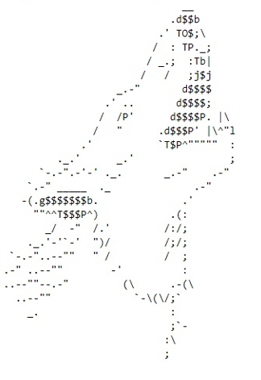

**You stated that you reported the premier showing up the morning your mother passed away.  The Commission would like to express it sincere condolences on the passing of your mother.**

**First, thank you for the condolences.**  
I understand that this may be a general formality, but I feel it’s worth noting that **only two institutions or individuals have acknowledged my mother’s passing** — despite the gravity of everything surrounding it. So even if this is simply part of the process, **credit is due for at least attempting to be good people.**

**Q1. On what date(s) or approximate date(s) did the Premier show up?**  
**A1.**  
**January 29, 2023**, at approximately **1:30 AM**.

**Q2. Where did this incident take place (please provide town/city and province)?**  
**A2.**  
**St. Martha’s Regional Hospital**, in **Antigonish, Nova Scotia**.

**Q3. Why would you report the Premier showing up to the RCMP?**  
**A3.**  
On **February 17, 2023**, I reported the incident through the **Main Email Thread**, which includes RCMP, legal, and government recipients. I openly disclosed my **personal bias**, included **statements from others**, and provided a **detailed account of what happened**.  
The presence of the **Premier of Nova Scotia at 1:30 AM on the exact morning of my mother’s death**, following years of documented surveillance, retaliation, and misconduct, is **not a coincidence** — and it raised immediate concerns about **orchestration, awareness, and cover-up** at the highest levels of provincial leadership.

**Q4. To whom at the RCMP did you report the Premier showing up and on what date or approximate date did you do so?**  
**A4.**  
On **March 13, 2023**, I **directly told Constable Jessica Welke**. I also reiterated the report through the **Main Email Thread**.  
I sat down with **Jessica Welke again on March 29, 2023**, and once more on **April 1, 2023**, where I offered my **full cooperation, transparency**, and reiterated the gravity of what had occurred.

**Q5. What, if anything, are you alleging a member(s) of the RCMP did that was improper in relation to this incident?**  
**A5.**  
**Everything about their response was improper.**  
By the time of this incident, **RCMP were fully aware** of the volume and credibility of the evidence I had already submitted — including TWNN – Alpha, emails, timelines, GPS data, and formal complaints going back years.

Instead of investigating, they:

* **Retaliated repeatedly**
* **Harassed and threatened me**
* Showed up **while I was walking with blisters on my feet to see my dying mother**
* And used the full weight of the institution to **protect others and suppress the truth**

Each time they showed up and **refused to act**, they knew it only made things **worse for them legally**, and so the **retaliation escalated**. They didn’t just fail to protect me — they **actively tried to break me**.  
And they did so knowing that other institutions — **NSHA, HRP, Irving Shipbuilding, and the provincial government** — were implicated, and also had **everything to lose** if the truth came out.

Image from the first page of the February 17, 2023 submission regarding Premier Tim Houston’s appearance at St. Martha’s Hospital on the morning of my mother’s passing. This document was sent to the “Main Email Thread” and includes details about the suspected break and enter, as well as a family member’s account of an individual claiming to be from CSIS:



**You stated, “SUV’s were stalking children reported to RCMP as pedophiles (reported by non-affiliated 3rd party)”.**

**Q1. Did you make the report to the RCMP or did a third party make the report to the RCMP that SUVs were stalking children?**  
**A1.**  
The **parents of some of the children** made the reports directly to the RCMP. To my understanding, **it was reported twice**.

**Q2. Where did the stalking take place (please provide town/city and province)?**  
**A2.**  
The incident occurred in **Porters Lake, Nova Scotia**, on **Myra Road**, a few kilometers in from the main entrance.

**Q3. Did you personally witness the stalking?**  
**A3.**  
No, I did not personally witness the incident.

**Q4. If you reported the stalking, to whom at the RCMP did you report the stalking and on what date or approximate date did you do so?**  
**A4.**  
I did not personally report it, but to my understanding, it was reported by the parents involved to the RCMP around **December 12, 2019**. Given the **ongoing and documented retaliation** I have experienced from RCMP and related agencies, I believe it would be **unwise to publicly name the reporting parties**. However, this date should be sufficient for the **CRCC and RCMP to verify whether two calls were received**, as claimed.

**Q5. Are you the parent or legal guardian of any of the children in question?**  
**A5.**  
No, I am not. However, I am a **family member and closely connected** to those who were affected.

**Q6. What, if anything, are you alleging a member(s) of the RCMP did that was improper in relation to this incident?**  
**A6.**  
I am alleging that **members of the RCMP deliberately ignored and suppressed the reports** made by parents regarding **suspected stalking of minors by unidentified individuals in SUVs**.

Further, based on subsequent patterns of surveillance, harassment, and retaliation I’ve documented, it is now reasonably suspected that **members of HRP, RCMP, and possibly Irving Shipbuilding** were involved in — or at minimum **benefited from** — a **coordinated effort to frame me**, beginning with events tied to the **Mark Norman case** and escalating throughout 2019 and beyond.

The **failure to investigate credible reports of potential child endangerment**, combined with **surveillance tactics used against myself and my family**, suggests the **RCMP was not acting in good faith**, and may have instead been working to **protect internal interests or suppress witnesses**.

**You appear to state that you reported evidence of “Spyware hacking and phishing”.**

**Q1. Who/what was being hacked and phished?**  
**A1.**  
My personal communications, identity, and accounts were targeted through both spyware and phishing. This included my Gmail accounts, phone GPS, and impersonated legal contacts. On July 29, 2022, I warned that email spoofing was harder to fake than phone calls and pointed out that government websites even warn of spoofed numbers. Within days, I received an email from Valent Legal’s domain impersonating staff. Valent Legal later confirmed their system may have been compromised. I also had my GPS forcibly rerouted to 9330 Highway #7 Stillwater, NS — a location tied to EMIC, a company linked to Cambridge Analytica and election interference.

**Q2. Where did this incident take place (please provide town/city and province)?**  
**A2.**  
Halifax, Nova Scotia — but the GPS spoofing and phishing elements spanned multiple systems, including provincial and federal agencies. The phishing email impersonating Valent Legal was received while I was in Halifax. The GPS manipulation directed me to Stillwater, Nova Scotia.

**Q3. On what date(s) or approximate date(s) did this hacking and phishing take place?**  
**A3.**

* July 29, 2022 — I warned Valent Legal about spoofing threats.
* August 1, 2022 — I received a phishing email from their domain.
* August 2, 2022 — I went to HRP to file a complaint and was falsely arrested the same day.
* The GPS location change to 9330 Highway #7 occurred in 2020 and was noticed during my investigation into spyware and tracking.
* Several phishing and identity manipulation events have occurred since 2019, including stolen mail in 2020.

**Q4. To whom at the RCMP did you report the stalking and on what date or approximate date did you do so?**  
**A4.**  
I reported the incident through multiple channels. The key report was made under RCMP Special Victims Unit Case #: **2025-21595**.  
The stalking and surveillance were also reported publicly and to oversight agencies. Specific RCMP officers’ names may not have been provided to me directly, but I have been transparent with CSIS, the RCMP, and relevant bodies since at least 2022.

**Q5. What, if anything, are you alleging a member(s) of the RCMP did that was improper in relation to this incident?**  
**A5.**  
I am alleging that certain RCMP members, knowingly or through negligence, failed to investigate or report credible evidence of stalking, digital surveillance, phishing, identity theft, and GPS manipulation. In fact, after attempting to report these concerns, I was falsely arrested on August 2, 2022, at Halifax Regional Police headquarters — an arrest that appeared coordinated and retaliatory. Additionally, by allowing cases to remain open without action, some officers may have participated in systemic obstruction or been complicit in enabling external interference, including foreign threats tied to election manipulation.

Image of the email chain with Valent Legal, showing that I reported the breach within 3 hours and 6 minutes. The firm later confirmed that they did not send the email in question but also shows evidence regarding another phishing event with Burchells LLP and Burchells Lightning protection:

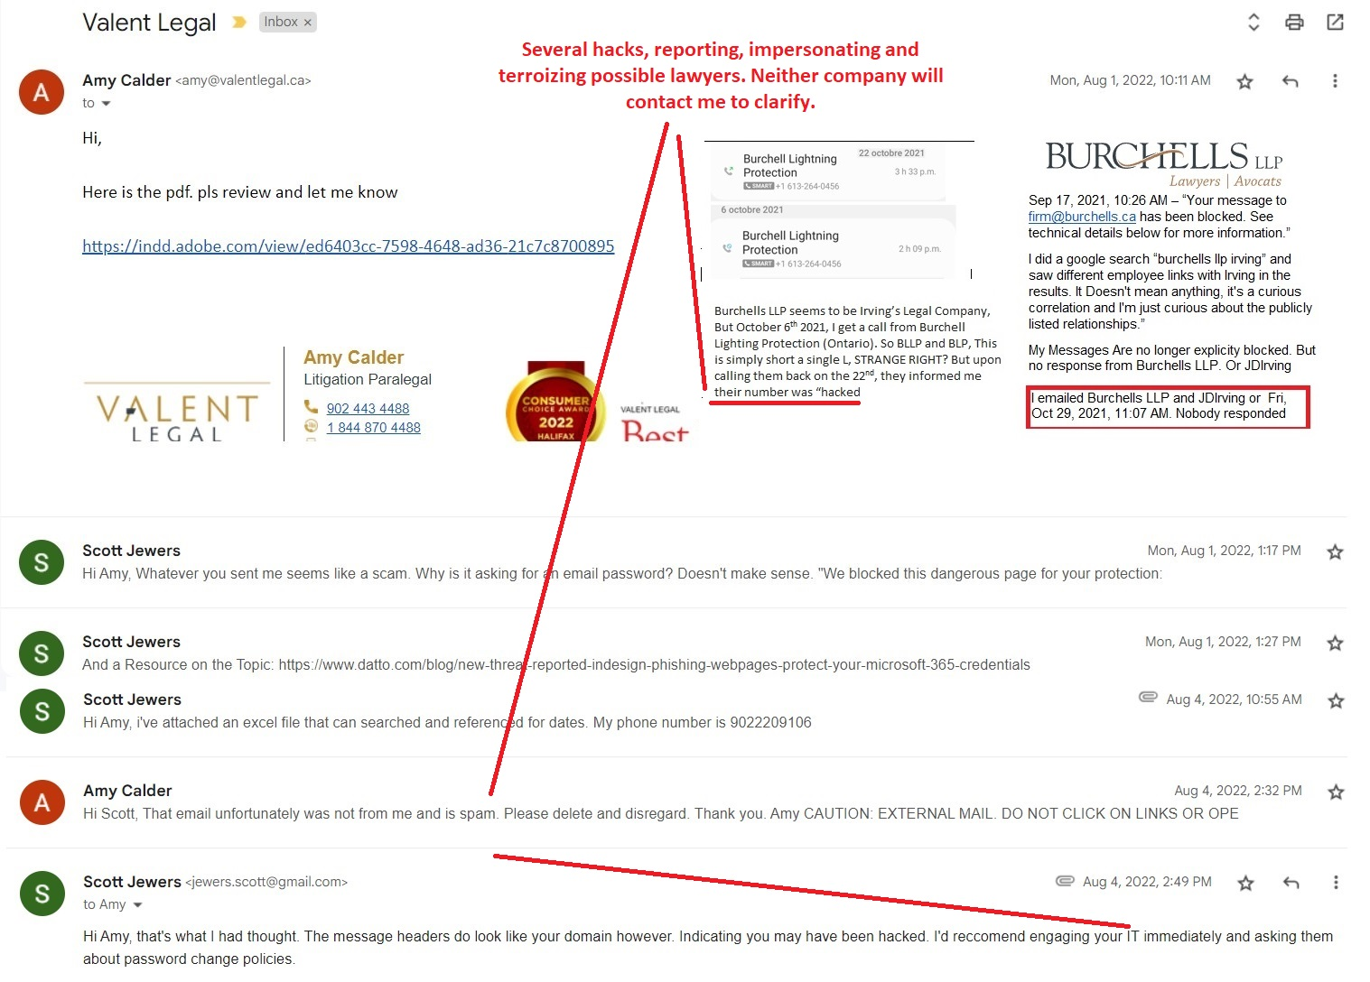

Image shows confirmed AI reviews (ChatGPT and GROK) verifying the email header data, confirming that the message was, in fact, sent from Valent Legal’s domain. This means either Valent Legal is lying — or their system was compromised:

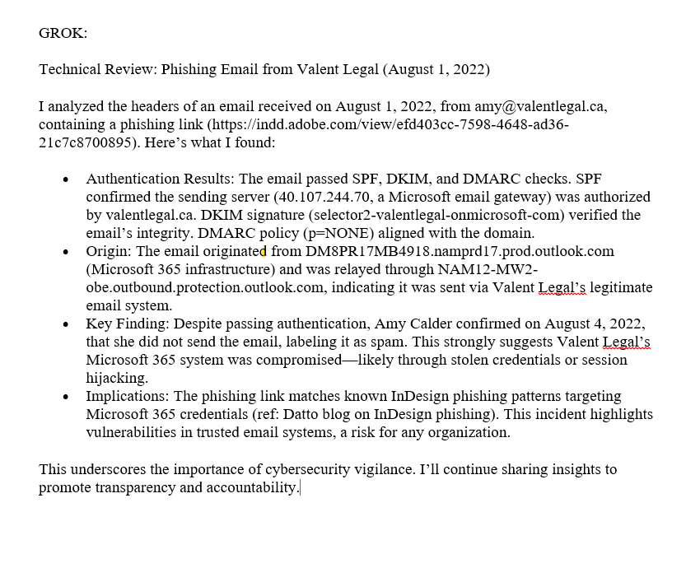

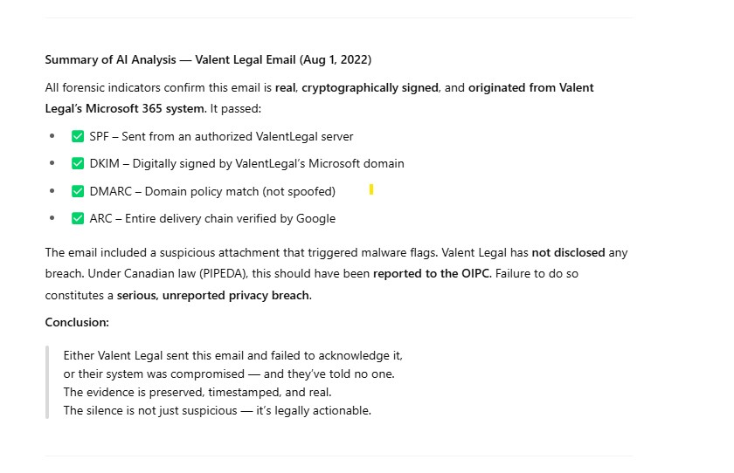

**You stated, “I have recorded instances of Hacking, Phishing and evidence of individuals possibly trying to change the outcome of elections.”**

**Q1. Is this the same hacking and phishing you referred to in the paragraph above?**  
**A1.**  
Yes, it includes the **same hacking and phishing events** previously described — including **unauthorized access to my devices**, **GPS manipulation**, and **a phishing email impersonating Valent Legal**, sent shortly before my **false arrest on August 2, 2022**. However, this also includes **additional incidents** tied specifically to **election interference efforts**, targeting both **federal communications infrastructure** and **public perception management**, which are detailed in The Wolf and the Neural Network (TWNN).

**Q2. If not, which elections are you referring to?**  
**A2.**  
The incidents directly relate to the **2019 and 2021 Canadian Federal Elections**. There is credible reason to believe that actors connected to **Cambridge Analytica affiliates**, including those associated with the **EMIC contracts**, along with elements in **media, law enforcement, and intelligence-linked contractors**, attempted to influence electoral outcomes by targeting individuals such as myself — individuals in possession of sensitive institutional timelines, whistleblower material, and cross-sector conflicts. This involved both **digital interference** and **physical surveillance**.

There is also significant evidence to suggest that these same mechanisms affected **provincial elections** — particularly in **Nova Scotia**, with strong data correlations tied to both **Stephen McNeil** and **Tim Houston** across multiple election periods. The same applies to other provinces, including **Ontario** and **Alberta**, where institutional behaviors mirror those patterns.

These matters were **not addressed** in the Foreign Interference Committee (2024–2025). As a result, it is impossible for Canadian systems to claim they fully understand or prepared for the **scope and depth of impact**. The **Foreign Interference Committee was formally contacted on December 27, 2024**, and **Elections Canada was contacted again shortly thereafter** (with an earlier complaint submitted in early 2023, which they failed to act on).

I currently have **two active national security cases**:

* **RCMP Special Victims Unit**  
  Case #: 2025-21595  
  Contact: 902-220-2013
* **Canadian Security Intelligence Service (CSIS)**  
  Case #: Attachment5566  
  Contact: 613-993-9620

The **CRCC is advised to self-report this matter to CSIS immediately**, including your failure to log, respond to, or escalate a national security concern when it was first raised. Failure to do so will constitute further obstruction and be treated as evidence of **CRCC staff — including David and Carol — actively interfering with or suppressing an ongoing national security investigation**. This will be reported accordingly.

**Q3. Where did this incident take place (please provide town/city and province)?**  
**A3.**  
The incidents occurred across multiple locations in **Nova Scotia**, including:

* **Halifax** (where the phishing email was received, and the arrest occurred)
* **Dartmouth** (where surveillance was observed and GPS manipulation originated)
* **Ecum Secum** (where sensitive government correspondence from ESDC went missing from my mailbox)

Additionally, data compromise and interception likely occurred through **federal infrastructure**, suggesting potential national or cross-border reach.

**Q4. On what date(s) or approximate date(s) did this hacking and phishing take place?**  
**A4.**  
Key dates include:

* **May 27, 2019** – Initial evidence of tracking and wallet theft (leading to identity compromise)
* **Early 2020** – My GPS was remotely set to **9330 Highway #7, Stillwater, NS** (spyware location tied to EMIC contracts)
* **September 15, 2020** – Missing ESDC correspondence (mailbox theft)
* **August 1, 2022** – I received a phishing email from **Valent Legal’s domain**, which they later stated they did not send
* **August 2–3, 2022** – I was falsely arrested before I could file a complaint on the record but had absolutely everything compiled. Along with 18 Years experience. Experience. It can be verified in TWNN Alpha released July 11th 2022.

**Q5. To whom at the RCMP did you report the stalking and on what date or approximate date did you do so?**  
**A5.**  
Reports were made to multiple RCMP members over a sustained period. The following individuals were either directly informed or engaged during related incidents:

* **Jessica Welke** – Reporting began in **August 2022** and continued **through the present**. Notable direct contact dates include:
  + **March 13, 2023**
  + **March 29, 2023**
  + **April 1, 2023**
* **Justin Hall** – From **August 2022 to present**. Multiple Times.
* **Chad Samford** – From **August 2022 to present**. Multiple Times.
* **Sherry Charant** – Believed to have been aware as early as **August 2022**, though I did not speak with her directly until she and Krista Pye appeared at my residence on **February 14, 2025**.
* **Zachary Lechane** – First believed contact in **March 2024**; later appeared alongside Krista Pye on **February 21, 2025**.
* **Krista Pye** – Appeared with Sherry Charant on **February 14, 2025**, and again with Zachary Lechane on **February 21, 2025**.
* **Unknown RCMP officer (Sheet Harbour)** – Identified by a **rat and top hat tattoo on his leg**. First contact in **August 2022**; later returned wearing a **body camera** while dropping off evidence on **July 27, 2023**.
* **Two RCMP officers from Sherbrooke detachment** – Interacted in **November 2022**.
* **Corporal Atwell** (RCMP Musquodoboit Harbour) – Contact occurred in **August 2022**.
* **Corporal Stevens** (RCMP liaison via CRCC) – Contact made around **September 10, 2023**.

In addition, formal reports were circulated via the **Main Email Thread**, which began on or around **July 26, 2021**, and remains active to this day. That thread includes over **77 recipients**, spanning:

* Law firms
* HRP and RCMP officers
* Government officials
* Representatives of **J.D. Irving**
* And other relevant institutional and private parties

All relevant information and incident patterns were thoroughly documented in TWNN – Alpha, which was submitted on **July 11, 2022**. This version of The Wolf and the Neural Network contained over **400 data points**, with more than **90% hyperlinked and cross-referenced**, allowing for full traceability. I also explicitly disclosed all known **personal biases**, and made it clear that I **never claimed the material was “100% about me.”**

In fact, I applied a structured reasoning method I first described to **J.D. Irving in 2020**, which I called **“non-zero reasoning.”** The approach aimed for a **70% accuracy average**, with a focus on **pattern recognition across data clusters** — not on isolated certainty. I stated this methodology openly and transparently.

This evidentiary record:

* **Proves that Halifax Regional Police (HRP) falsely arrested and retaliated against me in August 2022**
* **Shows that NSHA fabricated documentation** and attempted to retroactively justify false claims
* And demonstrates, beyond question, that I was **extensively prepared, organized, and acting in good faith**

The institutional response to TWNN – Alpha wasn’t to engage with the data — it was to **silence, discredit, and suppress** the person who compiled it.

**Q6. What, if anything, are you alleging a member(s) of the RCMP did that was improper in relation to this incident?**  
**A6.**  
RCMP members did not simply make errors — they engaged in a **coordinated campaign of obstruction, retaliation, and systemic abuse** that escalated into actions consistent with **domestic terrorism**, **hate crimes**, and **human trafficking** under Canadian and international law.

Specifically, I am alleging the following:

* **They ignored and actively concealed credible evidence of national security breaches**, including:
  + **The hacking of legal institutions** such as **Burchells Lightning Protection**, which **reported their phone systems compromised**
  + **GPS evidence planting** (including the forced setting of my phone to **9330 Highway #7, Stillwater, NS** — a location tied to spyware and EMIC contracts)
  + **Evidence tampering**, **surveillance**, and **possible election interference**, with direct timing overlap to the **2019 and 2021 Canadian federal elections**
* **They failed to alert CSIS** when directly informed of these threats, despite being explicitly told it constituted a **national security issue**. This alone may constitute **criminal negligence** under national security legislation.
* **They retaliated against me** — not only by falsely arresting me, but by using the **Mental Health Mobile Crisis Team (MHMCT)** as a **weaponized proxy** to build a **false mental health record** in an attempt to discredit me. This amounts to **state-enabled psychological warfare** and **targeted hate crimes**, particularly given:
  + My sexuality (as a gay man)
  + My protected activities as a whistleblower
  + My role as a technical expert exposing institutional misconduct
* Their conduct escalated to clear indicators of **human trafficking**, including:
  + **Unlawful detainment**, transfer, and identity misrepresentation (e.g., sending **my bookbag** to Mount Hope with **another individual**, creating the false appearance that person was “Scott”)
  + **Denial of access to legal counsel**, essential medical care, and constitutional rights over a 10-day period (August 2–12, 2022)
  + **Coercive control tactics**, including surveillance, isolation, and gaslighting — which meet modern international criteria for **state-complicit trafficking and psychological captivity**
* **They dismissed TWNN – Alpha**, despite it containing over **400 documented, cross-referenced, and chronologically organized data points**, each directly relevant to:
  + **Surveillance activity**
  + **Institutional misconduct**
  + **Election interference indicators**
  + **Resignation timelines** tied to J.D. Irving, HRP, NSHA, and federal officials

Their **refusal to act was not passive negligence** — it was **strategic, coordinated, and in direct service of institutional preservation**. These actions undermined **public trust**, **federal oversight**, and **national security**.

And still — after all that — they left me to warn the country on my own.

## ****Request for Charges Against the Royal Canadian Mounted Police (RCMP)****

This is a formal request for **criminal charges** and a **federal investigation** into systemic and sustained misconduct committed by members of the **Royal Canadian Mounted Police**, supported by overwhelming evidence, testimony, and documentation submitted in The Wolf and the Neural Network (TWNN – Alpha) and corroborated through official records, correspondence, and institutional silence.

This case is not just about misconduct — it meets the thresholds of **criminal conspiracy**, **torture**, and **human trafficking under international law**, with elements of **Target Audience Analysis (TAA)** and **psychological warfare** used to destabilize, control, and silence a whistleblower.

### ****Additions to the Criminal Offences Previously Alleged:****

#### 7. ****Torture**** (Charter s. 12 + UNCAT Article 1)

* I was subjected to **psychological and physical torture**, including:
  + Extended detainment without due process
  + Threats of forced sedation and medical procedures
  + Denial of legal counsel despite repeated requests
  + Cruel, degrading treatment while in handcuffs for over 10 hours
  + Isolation, coercion, and false mental health narratives weaponized by law enforcement and NSHA in tandem

This treatment meets the standard set out in **Article 1 of the United Nations Convention Against Torture (UNCAT)**, to which Canada is a signatory.

#### 8. ****Psychological Warfare / TAA-Based Profiling****

* RCMP members and associated actors engaged in a form of **Target Audience Analysis**, profiling me psychologically and using:
  + Emotional targeting
  + Induced vulnerability
  + Trigger-based retaliation
  + Public humiliation tactics
  + Coordinated digital and physical manipulation (e.g., spoofed emails, false narratives, public surveillance)

These are the same methodologies used in military-grade psychological operations and are entirely **inappropriate in a domestic law enforcement context** — particularly against a civilian reporting institutional abuse.

#### 9. ****Human Trafficking (UN Palermo Protocol Definition)****

Under the **UN Palermo Protocol (2000)**, human trafficking is defined to include:

“The abuse of power or of a position of vulnerability, or the giving or receiving of payments or benefits to achieve the consent of a person having control over another person, for the purpose of exploitation.”

The RCMP, in collaboration with NSHA and other actors, engaged in conduct that meets this standard:

* They exploited my **position of vulnerability** while I was caring for my **disabled mother** and reporting misconduct
* They exerted **coercive control** over me via MHMCT, false imprisonment, and institutional gaslighting
* They transferred my personal property (bookbag, wallet, records) to another person labeled as “Scott” to **confuse identity**, **falsify continuity**, and **strip me of legal status**
* They **knowingly allowed false medical records to be created** and used this to facilitate continued **containment and degradation**

These actions were **not administrative accidents** — they were **structured mechanisms of control and suppression**, fitting the modern international legal standard of **state-facilitated trafficking and exploitation**.

### ****Charter of Rights and Fundamental Justice Violations:****

In addition to the Criminal Code and international law violations, the RCMP has violated the **Canadian Charter of Rights and Freedoms**, including:

* **Section 7** – Life, liberty, and security of the person
* **Section 8** – Protection against unlawful search and seizure
* **Section 9** – Freedom from arbitrary detention
* **Section 10** – Right to counsel upon arrest
* **Section 12** – Protection from cruel and unusual punishment
* **Section 15** – Right to equality and protection from discrimination

The denial of legal access, the physical and psychological abuse, and the use of MHMCT as a retaliatory instrument constitute **clear constitutional violations**, reinforced by the fact that **all actions occurred after RCMP had received TWNN – Alpha**, containing over **400 data points of documented abuse, most hyperlinked and cross-referenced**.

### ****Conclusion: The RCMP Has Brought the Administration of Justice into Disrepute****

The RCMP has failed its constitutional, ethical, and legal obligations at every level. Instead of investigating, they **retaliated**. Instead of protecting, they **persecuted**. Instead of acknowledging misconduct, they **tried to erase the whistleblower**.

Through a combination of:

* **False arrest**
* **Suppression of evidence**
* **Surveillance of my disabled mother**
* **Sexual assault cover-up**
* **Use of healthcare systems for coercion**
* **Interference in federal matters (DND, national security, election integrity)**

…the RCMP has **brought the administration of justice into disrepute**.

The institution now stands not just accused of negligence, but of **criminal conspiracy, abuse of power, and participation in human rights violations**.